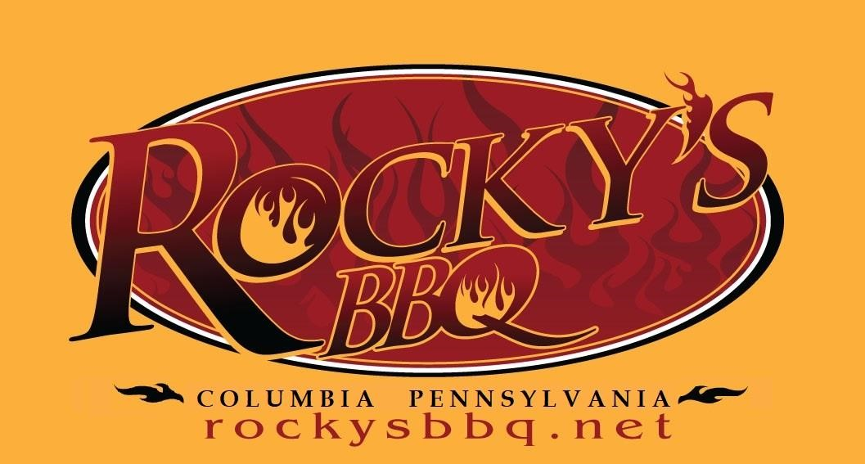

Sandwiches
Pulled Pork |  | $8.25*
Brisket |  | $12.50*
Slider Combo |  | $9.25*
One pork Slider, One brisket Slider
The Columbian $10.00*
Brisket & Choice of Sausage

House Made Sausage
2 Links $7.25*
Sausage Sandwich $6.00*
Single Link
Cup~O~Pork $7.00* Pork~n~Mac $8.75
Pulled Pork on top of Mac&Cheese
Burnt Ends $9.50* The Sparky $10.00
Burnt Ends on top of Mac&Cheese
Drinks $1.50
*Add $5.50-Choose 2 Sides

Pit Master Platter $27.00
Brisket, Pulled Pork, Spare Ribs,
1 Sausage Link, Slaw and Pickles

St. Louis Style Ribs
Full Rack | $25.00
Half Rack  Home Made Sides | $15.00
Mac&Cheese | $4.75
Rocky’s Smoked Beans | $4.25
Southern Dill Potato Salad | $4.25
Macaroni Salad | $4.25
Collard Greens | $4.75
Slaw | $2.50
Corn Cake | $2.75
With Apple Jalapeno Jam

